Session 2026-2027

Session | 2026-27 |  | Course Name | Web Technology Lab
Semester | 3 |  | Course Code | 23CT1301
Roll No | A29 |  | Name of Student | Unnati Goyanka
Practical Number |  | 4 A
Course Outcome |  | - Understand various internet technologies.  - Design the web pages using HTML and CSS.  - Implement the XML technology to store the data.  - Develop the interactive web pages using JavaScript.
Aim |  | To develop a registration form using HTML and JavaScript and validate the name, email, password, and phone number fields using conditional statements and loops, displaying suitable error messages when the entered data is invalid.
Problem Definition |  | The objective is to create a registration form containing fields for name, email, password, and phone number. JavaScript is used to check whether the entered information satisfies the required conditions when the form is submitted. Empty fields, invalid email formats, weak passwords, and incorrect phone numbers should generate inline error messages. Conditional statements such as if-else are used to make validation decisions, while loops can be used to examine characters or conditions repeatedly.
Theory  (100 words) |  | JavaScript is a scripting language used to make web pages interactive and dynamic. Conditional statements such as if, else if, and else are used to make decisions based on conditions. Loops such as for and while are used to repeat a set of statements. Form validation checks whether information entered by a user is correct before submission. JavaScript can validate required fields, email format, password length, and phone number format. The Document Object Model (DOM) allows JavaScript to access and modify HTML elements. Error messages can be displayed dynamically beside input fields. Client-side validation improves usability and helps prevent incorrect data from being submitted.
Procedure and Execution  (100 Words) |  | Step for Implementation:  • Create an HTML registration form with Name, Email, Password, and Phone Number fields.  • Add a Submit button to the form.  • Create spaces near each field for displaying error messages.  • Use JavaScript to select the form elements through DOM methods.  • Attach a submit event to the form.  • Check whether each field contains valid information.  • Use if-else conditions to validate individual fields.  • Use loops where required to examine characters or validate input.  • Display an appropriate error message beside an invalid field.  • Prevent form submission if any validation fails.  • Display successful submission information when all entered values satisfy the required conditions.
Code: 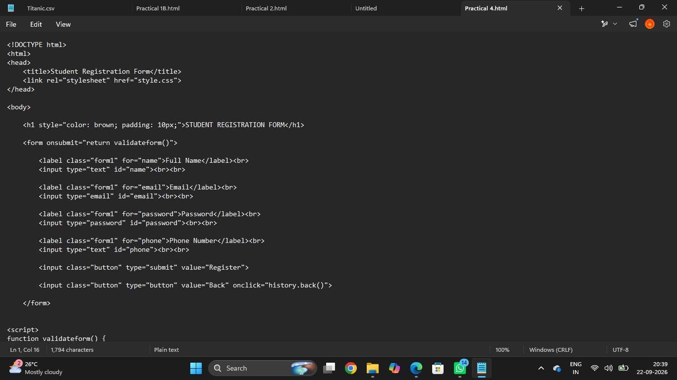


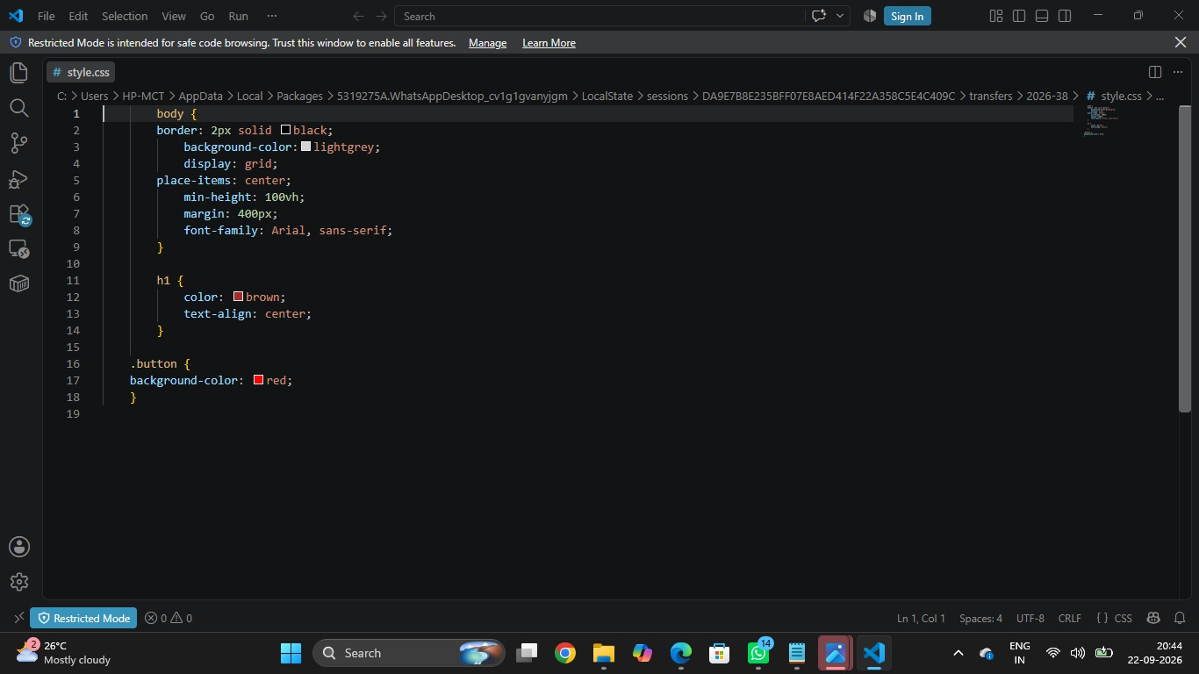

Output:

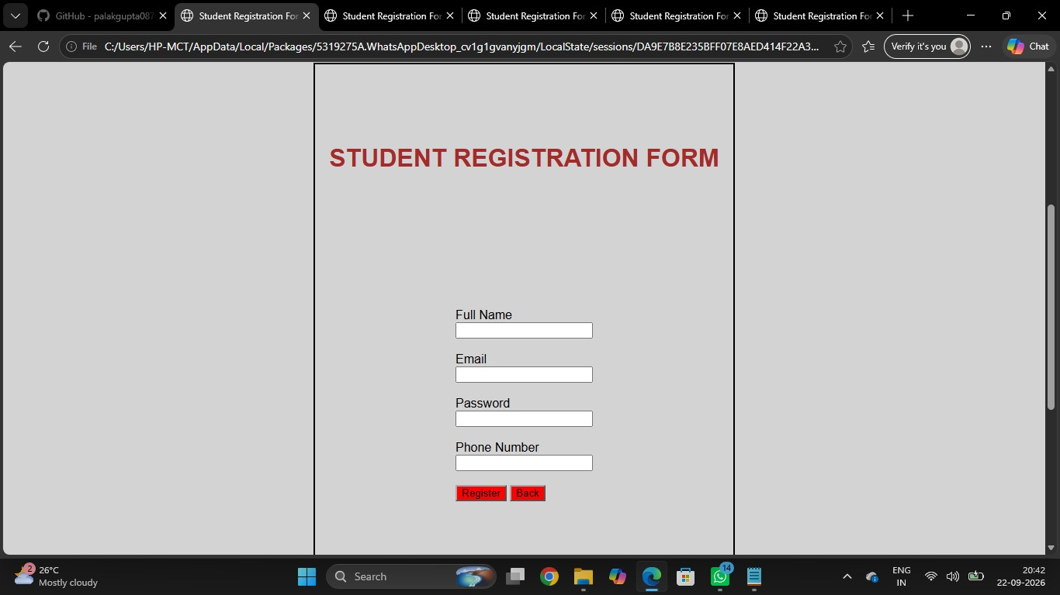
Output Analysis |  | The registration form successfully accepts Name, Email, Password, and Phone Number as input. When the Submit button is clicked, JavaScript checks each field. Empty or incorrectly formatted fields produce inline error messages beside the respective input boxes. A valid email must follow the required email pattern, while the password must satisfy the specified minimum length. The phone number is checked for the required number format. When all fields are valid, the validation errors are removed and a success message is displayed. Thus, JavaScript conditional statements and form-validation techniques work together to prevent invalid information from being submitted.
Link of student Github profile where lab assignment has been uploaded
Conclusion |  | The registration form was successfully developed using HTML and JavaScript. JavaScript conditional statements were used to check different validation conditions, while form validation ensured that the entered information followed the required format. Inline error messages made it easy for users to identify and correct invalid fields. This practical demonstrates how JavaScript can be used to create interactive and user-friendly web forms.
Plag Report (Similarity index < 12%) |  | The report content has been written in original wording for the practical.
Date |  | 03/08/2026

